Tip Sheet: Connecting to WebEx Training Center
Follow the directions below for connecting to your virtual training:
- Make sure you are in a distraction free environment and have high speed internet access.
- We strongly recommend you download the “Cisco Webex Meetings” app to your device. You will experience fewer issues using the app.
- Plan on joining at least 15 minutes before class starts to ensure you do not have any connection issues.
- Open your browser and go to https://mercymeetings.webex.com
- Under “Join a Meeting” Enter the Meeting Number and select “Join”
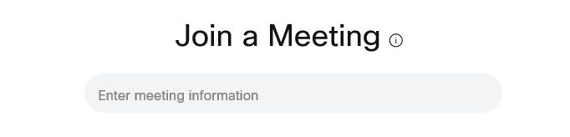
- Enter the Meeting Password
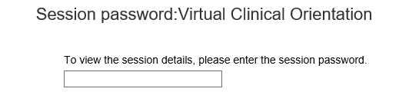
- On the right side of the screen under “Join Session Now”, enter your full legal name, email address, and the Meeting Password
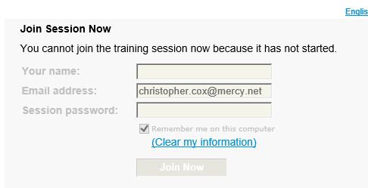

- Select “Join Now”

