

Logging into MyEducation

- Access MyEducation directly by going to:https://www.healthstream.com/HLC/Mercy
- Enter your Mercy user ID obtained from your leader into the User ID box
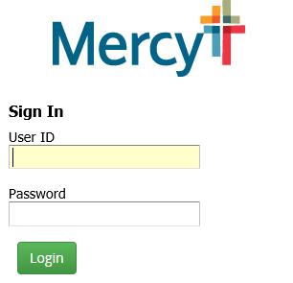

- For first time log-in, enter “Password1” in password box. This is case sensitive
- You will be prompted to change the password and create a new one.
- Your new password must contain:
  - at least six characters
  - one upper case letter and one lowercase letter
  - one number
- Log in with using your newly created password

- Complete assignments listed on your “To Do List” page. All assignments must be completed by the “Due Date”.

Mercy does not require a hard copy of any completion certificates.

